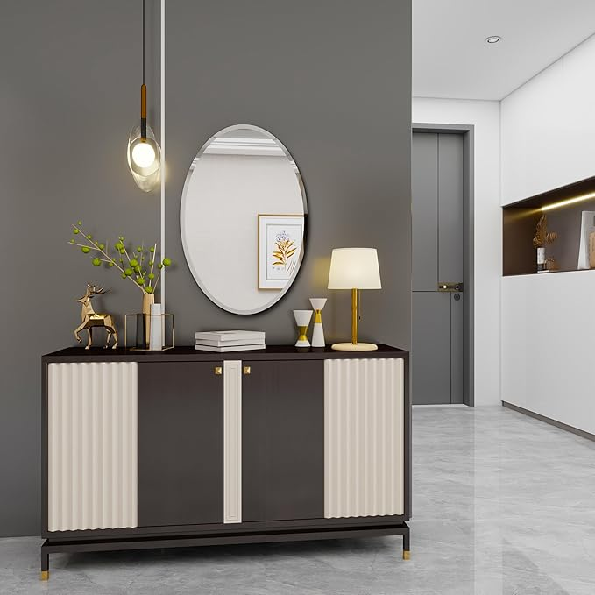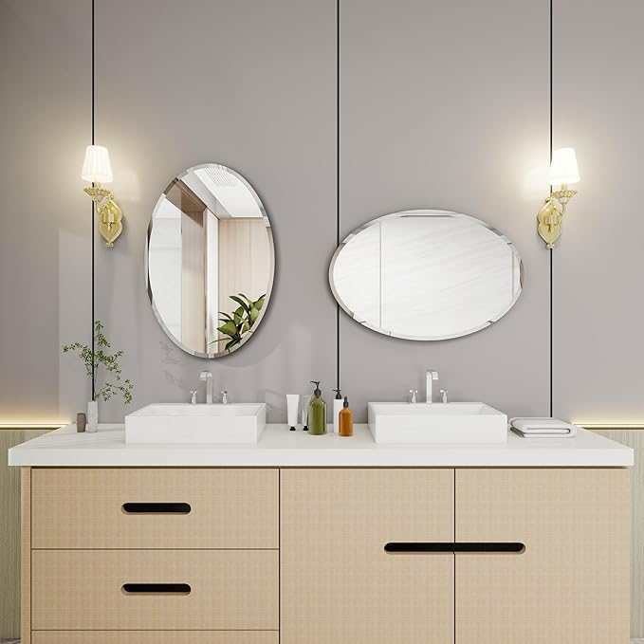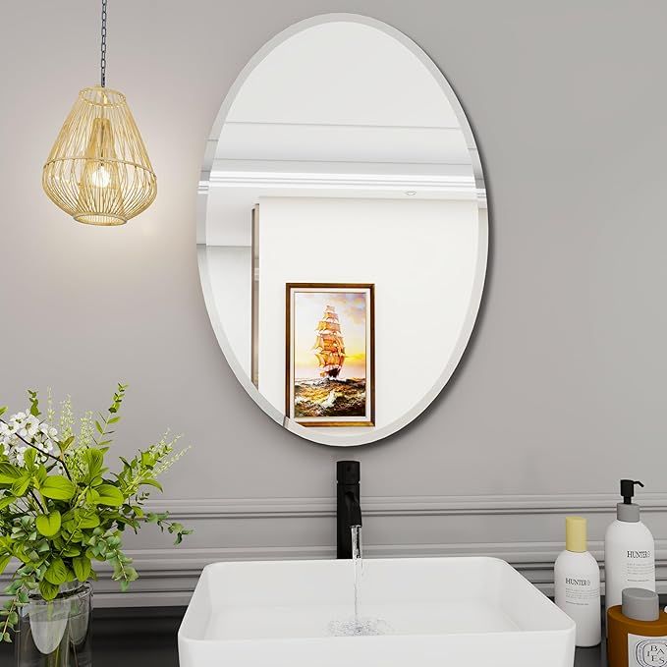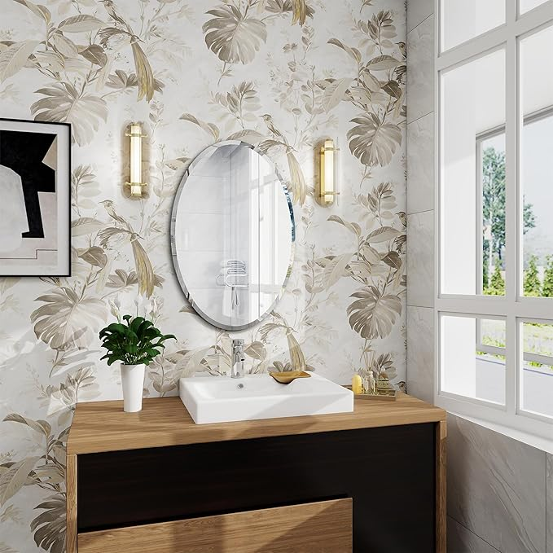

Mirrors for Bathroom Sink, 18X26 inch Oval Frameless Mirror, Small Bathroom Mirror, Suitable for Living Room Bedroom Entrance Mantel Corridor Decoration, Horizontal or Vertical Hanging

**PRODUCT DESCRIPTION:**

|  |  |
| --- | --- |
| Brand | YUNSHANGGE |
| Room Type | Bedroom |
| Shape | Elliptical |
| Product Dimensions | 18"L x 26"W |
| Frame Material | Metal |

**About this item**

* Elegant 18x26 Inch Oval Mirror: oval mirrorThis frameless oval mirror is perfect for your bathroom sink, oval mirrors for bathroom,adding a touch of sophistication. Its sleek design makes it an ideal small bathroom mirror, suitable for both modern and traditional decor.
* Versatile Wall Decor:oval bathroom mirror Our oval mirror is not just for bathrooms. oval bathroom mirrors for over sinkIts compact size and stylish design make it perfect for living rooms, bedrooms, entrances, mantels, or corridors. Hang it horizontally or vertically to fit your space.
* Space-Saving Solution: oval wall mirrorIdeal for small spaces, this oval mirror maximizes light and reflection, small oval mirrormaking your bathroom appear larger and more open. Its frameless design minimizes visual clutter for a clean look.
* Multi-Room Appeal: oval vanity mirrorAdd a touch of elegance to any room with this versatile mirror. bathroom mirror ovalIts neutral design complements any decor style, making it a great addition to your living room, bedroom, or hallway.
* Premium Quality: mirror oval.Crafted for durability and style, this oval mirror is designed to withstand daily use while maintaining its pristine appearance. oval mirrors for wallIts robust construction ensures it will be a reliable part of your home decor for years to come.